

**National University of Computer & Emerging Sciences**

**Karachi Campus**

**Group Members:**

Rafay Hussain (21k-3560)

Abdul Rafay (21k-3051)

M. Hassan (21k-3576).

**PROJECT REPORT:**

“C-PROGRAM SILENT INTERACTIVE AUCTION BOARD”

**Introduction:-**

A silent auction is an event at which items for sale are displayed for attendees to assess, place bids on, and purchase. However, unlike most auctions, there is no auctioneer present, and participants place their bids silently and anonymously on a bid sheet using a bidding number—hence the name silent auction.

Attendees at a silent auction spend the first part of the event checking out the items for auction. When they find something they’d like to place a bid on, they use their bidding number to make an anonymous bid on the bid sheet in front of the item. Text

**Problem analysis:-**

Silent auction are usually conducted by displaying the item and a paper in front of it for users to bid on. Which rose difficulties for participants for check for the highest bid in a huge list of bids. This was very time consuming. The program resolves this issue by displaying a board of item and their information which can help users to select the item and the amount they want to bid.

**Solution design:-**

This silent auction offers a user to bid silently. Different users can come and bid at any time. The management will enter information of the item in the auction.

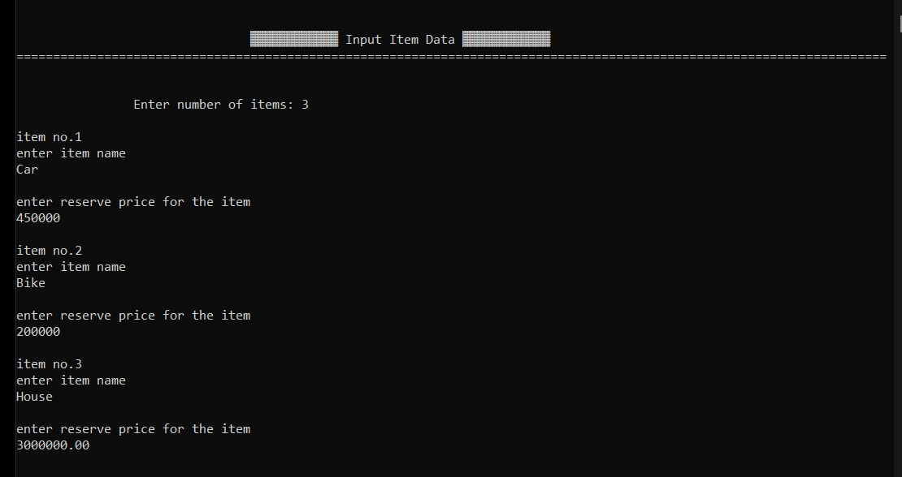

A menu screen is printed to easily navigate through the program.

Users will be allotted buyer IDs for bidding and identification Different users will bid by selecting the item number—However, Users can check reserved priced and highest bid on all the item printed on the auction board. The board will be updated after every bid. So that the user can bid accordingly.

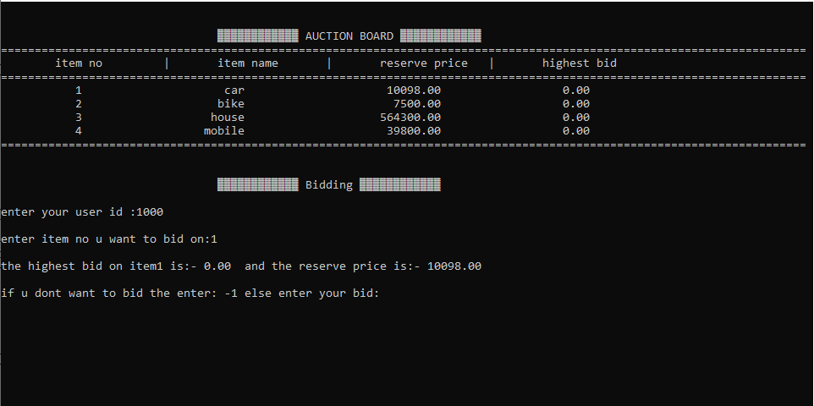

The feature suggestion facilitate user by helping user make up their mind in bidding on the item that is falling in their budget. The user can input their budget while registering for the auction or they can enter their budget at any given time during the auction if they feel like using this feature.

Few option on the menu screen can only be utilized by the management.

The management can see the information of all users during the auction which includes their names, ids, number of bids they have placed, and the item number they are currently winning.

The management will be responsible for ending the auction. Upon ending the auction the results are printed. Results will display the table for items, to whom those item are sold to and at what price.

**Implementation and testing:-**

Once the program has ended a file containing the results of auction and users’ info will be created to keep records. The features reserved for the authority requires a pin code that is set up before the start of auction. This assures the user that their information will not be disclosed.

The budget added by the users for suggestion will not be shared will the organizers as the budget is something personal and user might be insecure.

**Project breakdown:-**

All things were decided and implemented after mutual discussion. We broke this larger task in the chain of smaller tasks and completed them one by one. We divided the workload according to the working capacity of each individual. We used to have long discussions while planning and finalizing the things. We tried our best in distributing the workload and at last succeeded in it.

RESULTS:

• Had a whole new experience of developing a game

• Had a good experience of working in a team with cooperative team members

• Had a mass boost in skills

• This project helped us in gaining information and discovering good informational sources

**Conclusion:-**

We used the concepts taught to us in class to solve the problems in the code. We used built in libraries, user defined functions and user defined data type to create the program. We believe this program wil